Highcliffe School Student Bulletin

Monday 13th November - Friday 17th November 2006: Week B

Thought For The Week:
If there be any truer measure of a person than by what they do, it must be by what they give.

News Story of the Week:
Queen leads tributes to war dead
See http://news.bbc.co.uk/cbbcnews/hi/uk/default.stm
for more details and other news stories!
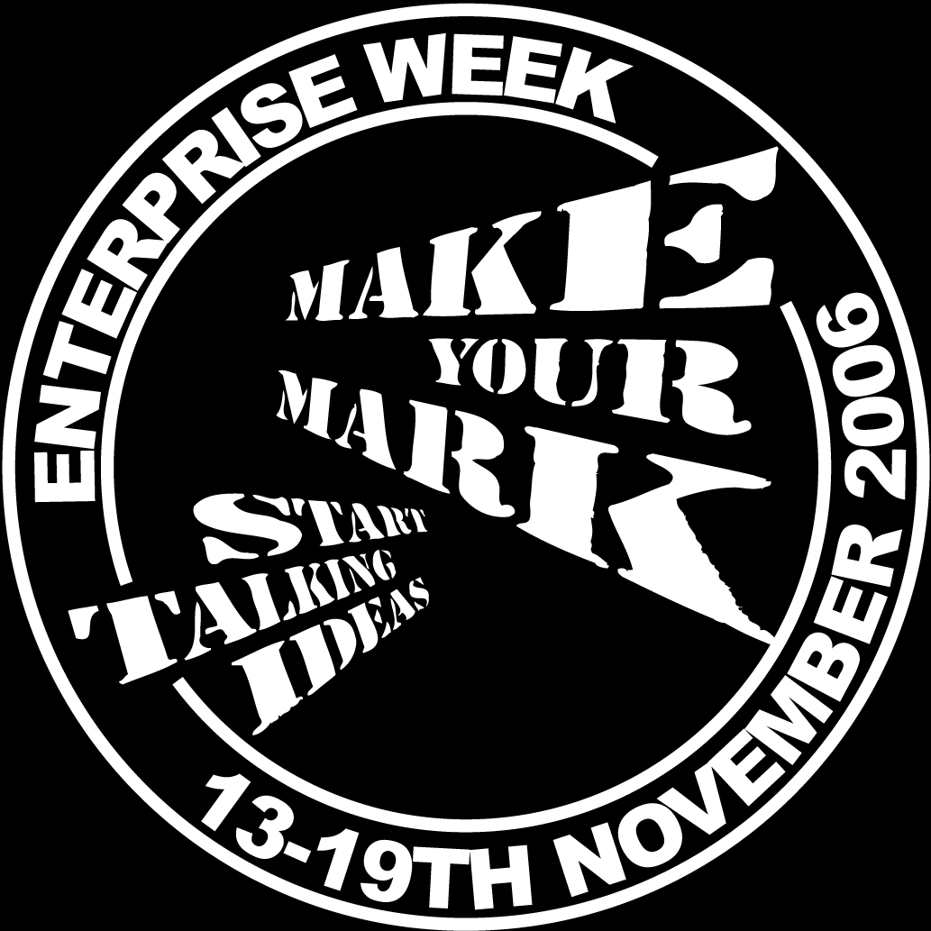

Enterprise Week - Make your mark - start talking ideas. This is the first year Highcliffe School has been involved in Enterprise Week on such a scale. Please support all the charity events and social enterprise initiatives that are going on this week (and later on in the year). Be proud to help make a difference to others.

Year 10 Mathematics Module 1 exam: Monday 13th November start 1.20pm Check seating plans on doors to dining area at breaktime / lunchtime. Line up silently at the appropriate venue in seating order. Remember this is a 3-2 day! Remember to bring calculator, pencil, ruler, eraser, pen, protractor, pair of compasses.

Shoebox Appeal: Thank you for all your support. So far we have sold over 400 boxes! Please buy the remaining boxes! Could all completed boxes be crossed off on the tutor group check lists and taken to the Library.

S-Factor: Serious Cereals! Can you make Rice Crispies fly or find the Iron in Special K? Come along & find out in SC10 Thursday at 3.25pm! All year 7, 8 & 9 students are welcome!

MUSIC NOTICES
Tuesday after school: Harmonious Funk Jazz Band in EX3 3.20-5.00pm
Wednesday lunchtime: SHOUT! vocal group in EX3 1.40-2.10pm
Wednesday after school: Vocalis vocal group FOR ALL WHO HAVE SMALL GROUP AND SOLO PARTS IN THE MUSICAL in EX3 3.20-5.00pm
Thursday lunchtime: Theory Workshop EX3 1.40-2.10
Thursday after school: rehearsal for those in CHORUS G in the musical 3.20 – 5.00pm EX3

SPORTS NOTICES

Results:
Year 10 netball v Ringwood - won

Year 9 netball v Arnewood - won
Year 7 rugby v Portchester (A & B teams) - won
Year 7 rugby v Ringwood (A & B teams) - won
Year 7 (A) netball v Arnewood (B) - won
Year 7 (B) netball v Arnewood (A) - lost
Year 7 netball (A) v Arnewood (A) - lost
Year 7 netball (B) v Arnewood (B) - won
Year 8 football v Budmouth (county cup) - won


BRAIN TEASER

If 2 karms equal 4 foz, and 1 foz equals 3 burs, how many karms are 24 burs?

Answers to be submitted with your name and tutor group in the Brain Teaser box in Ma6 Before Friday 17th November.

The winner of last week’s Brain Teaser was Chloe Shepherd of tutor group 96. Well-done Chloe!

ENLIGHTENING ECO-FACTS!!!

 On average every person in the UK throws away their own body weight in rubbish every 7 weeks.
Most of this ends up in landfill sites; produces methane-a greenhouse gas; and makes our planet look UGLY.

So think before you bin and reduce that waste!

